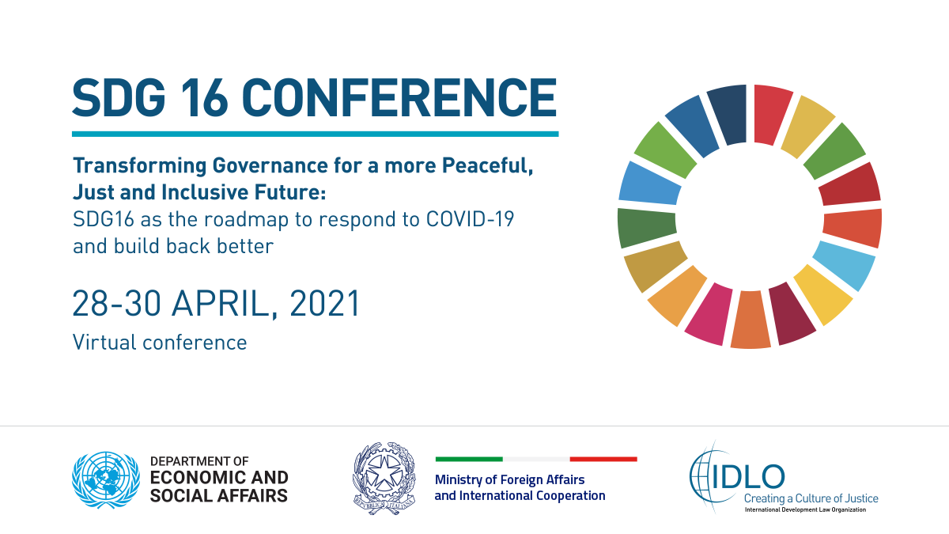
28 - 30 April, 2021 | ​14:00 - 19:00 CEST
Zoom webinar

Conference summary
Building on the outcomes of the first SDG 16 Conference held in Rome, Italy, in May 2019, the United Nations Department of Economic and Social Affairs (UNDESA), the International Development Law Organization (IDLO) and the Government of Italy are organizing a second SDG 16 Conference. The 2021 Rome Conference will consider the impact of the COVID-19 pandemic on SDG 16 as well as the transformative contribution SDG 16 can make in helping to safeguard and accelerate progress on the 2030 Agenda for Sustainable Development. It will contribute to the deliberations of the 2021 High-level Political Forum on Sustainable Development (HLPF), while aligning itself to the vision for the United Nations System and the wider international system in the years to come as mandated by the Declaration on the 75th Anniversary of the Organization.
The Conference will help to generate a preliminary assessment of how progress towards SDG 16 has been affected by COVID-19 and the pandemic’s wider implications for the realization of the 2030 Agenda. It will highlight the importance of policy orientations embodied in SDG 16 to efforts to build resilience to shocks and provide a roadmap for a more just, inclusive and equitable recovery required to sustain peace and development and deliver on Decade of Action to deliver the Global Goals.
Follow & Share @IDLO

